**Design patterns**

**Iterator**

**Location:** ganttproject/src/main/java/net/sourceforge/ganttproject/task

**Class:** CustomColumnsStorage.java

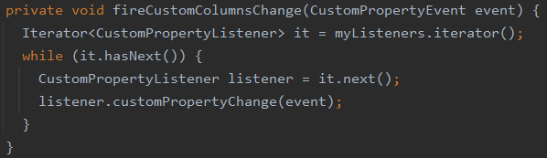

This method uses an Iterator to traverse a collection of objects of the CustomPropertyListener class, without exposing its internal properties.

**Façade**

**Location:** ganttproject-tester/test/net/sourceforge/ganttproject/chart/mouse

**Class:** ChangeTaskProgressRulerTest.java

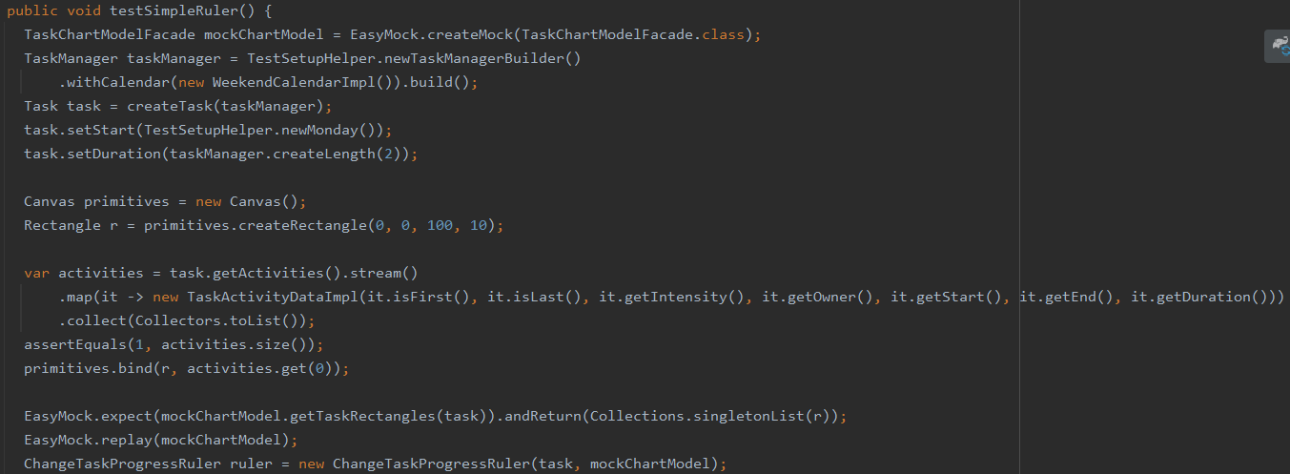

In this class, we can see the use of the Facade pattern when creating a TaskChartModelFacade object, with the purpose of accessing the subsystems of the mockChartModels easily and hiding their complexity.

**Singleton**

**Location:** ganttproject/src/main/java/net/sourceforge/ganttproject/gui

**Class:** GanttLooksAndFeels.java

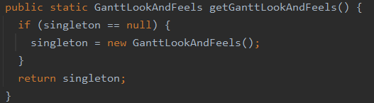

This class makes use of the Singleton pattern, by allowing the class to be instantiated only once, being the created object in this method the only global access point to this class.